Unit 6.4 : Air Pressure
Topic : Magic water glass trick
Worksheet 3
Name : _______________
Class : ____________( )
Date : ________________

Task 3: Blowing up balloon inside a bottle
Materials: A plastic bottle, tape, a balloon, a board nail
Procedure
1. Place a balloon into a plastic bottle.

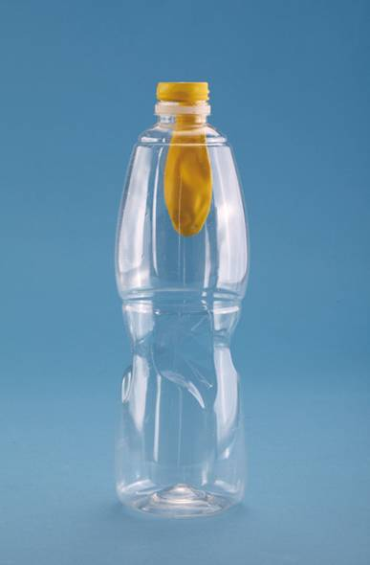

2. Predict what will happen if blowing air into the balloon. Explain your prediction.
It is difficult to blow up the balloon. There is air inside the bottle. The air pressure exerts a force on the balloon. Thus it is difficult to blow up the balloon.

3. Suggest a method to blow up the balloon easier. Explain your method.
Use a nail to make a hole at the bottom of the bottle. The air inside the bottle can go out from the hole. The air pressure exerting force on the balloon will diminish.

